Homework 5

# Problem I Micro-Instruction Controller

1a) The register is loaded with value 0000.

The OR gates select the higher priority when they are Y4..Y7. Then the A bit is from the OR of Y4..7.

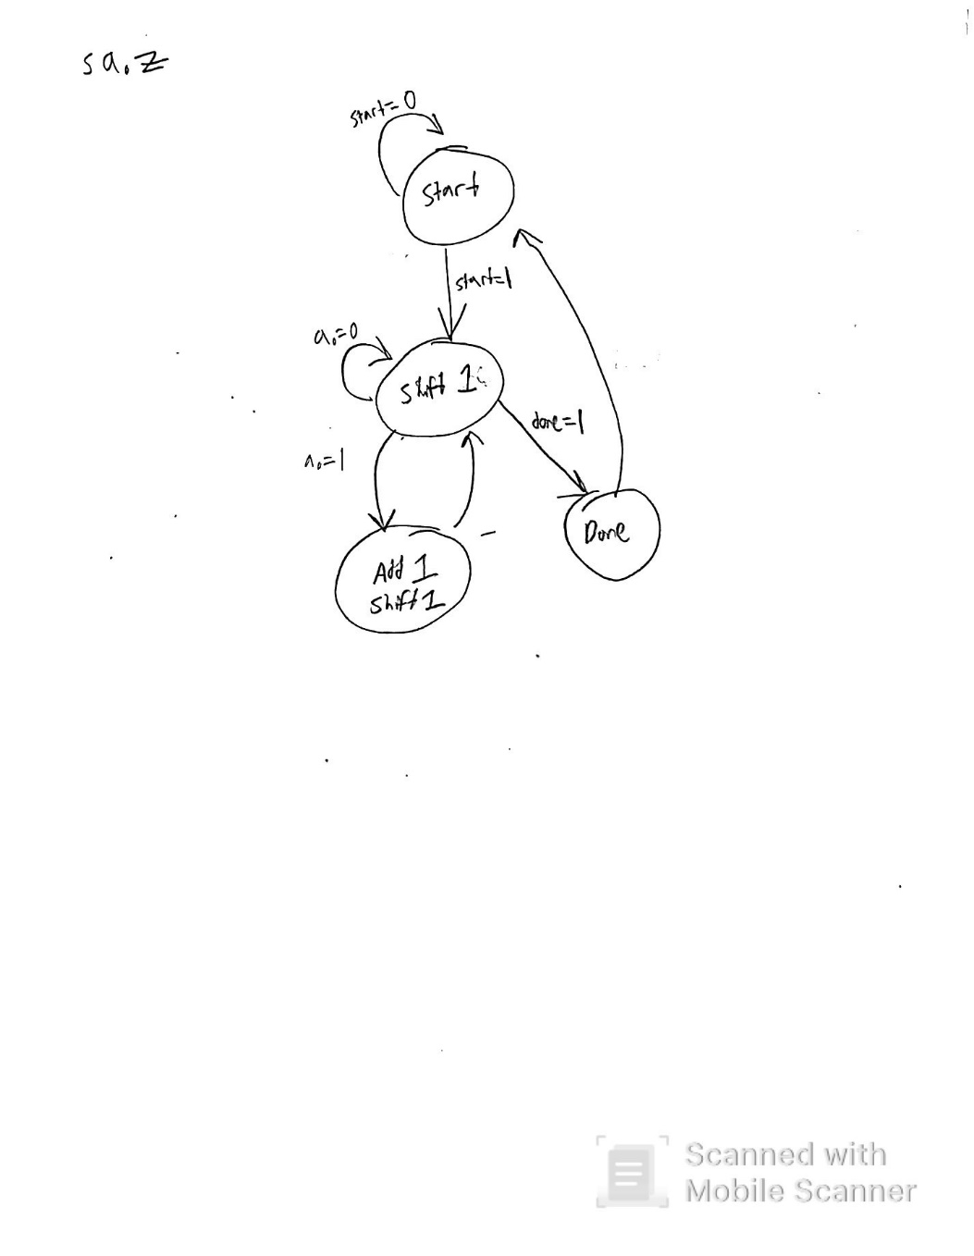

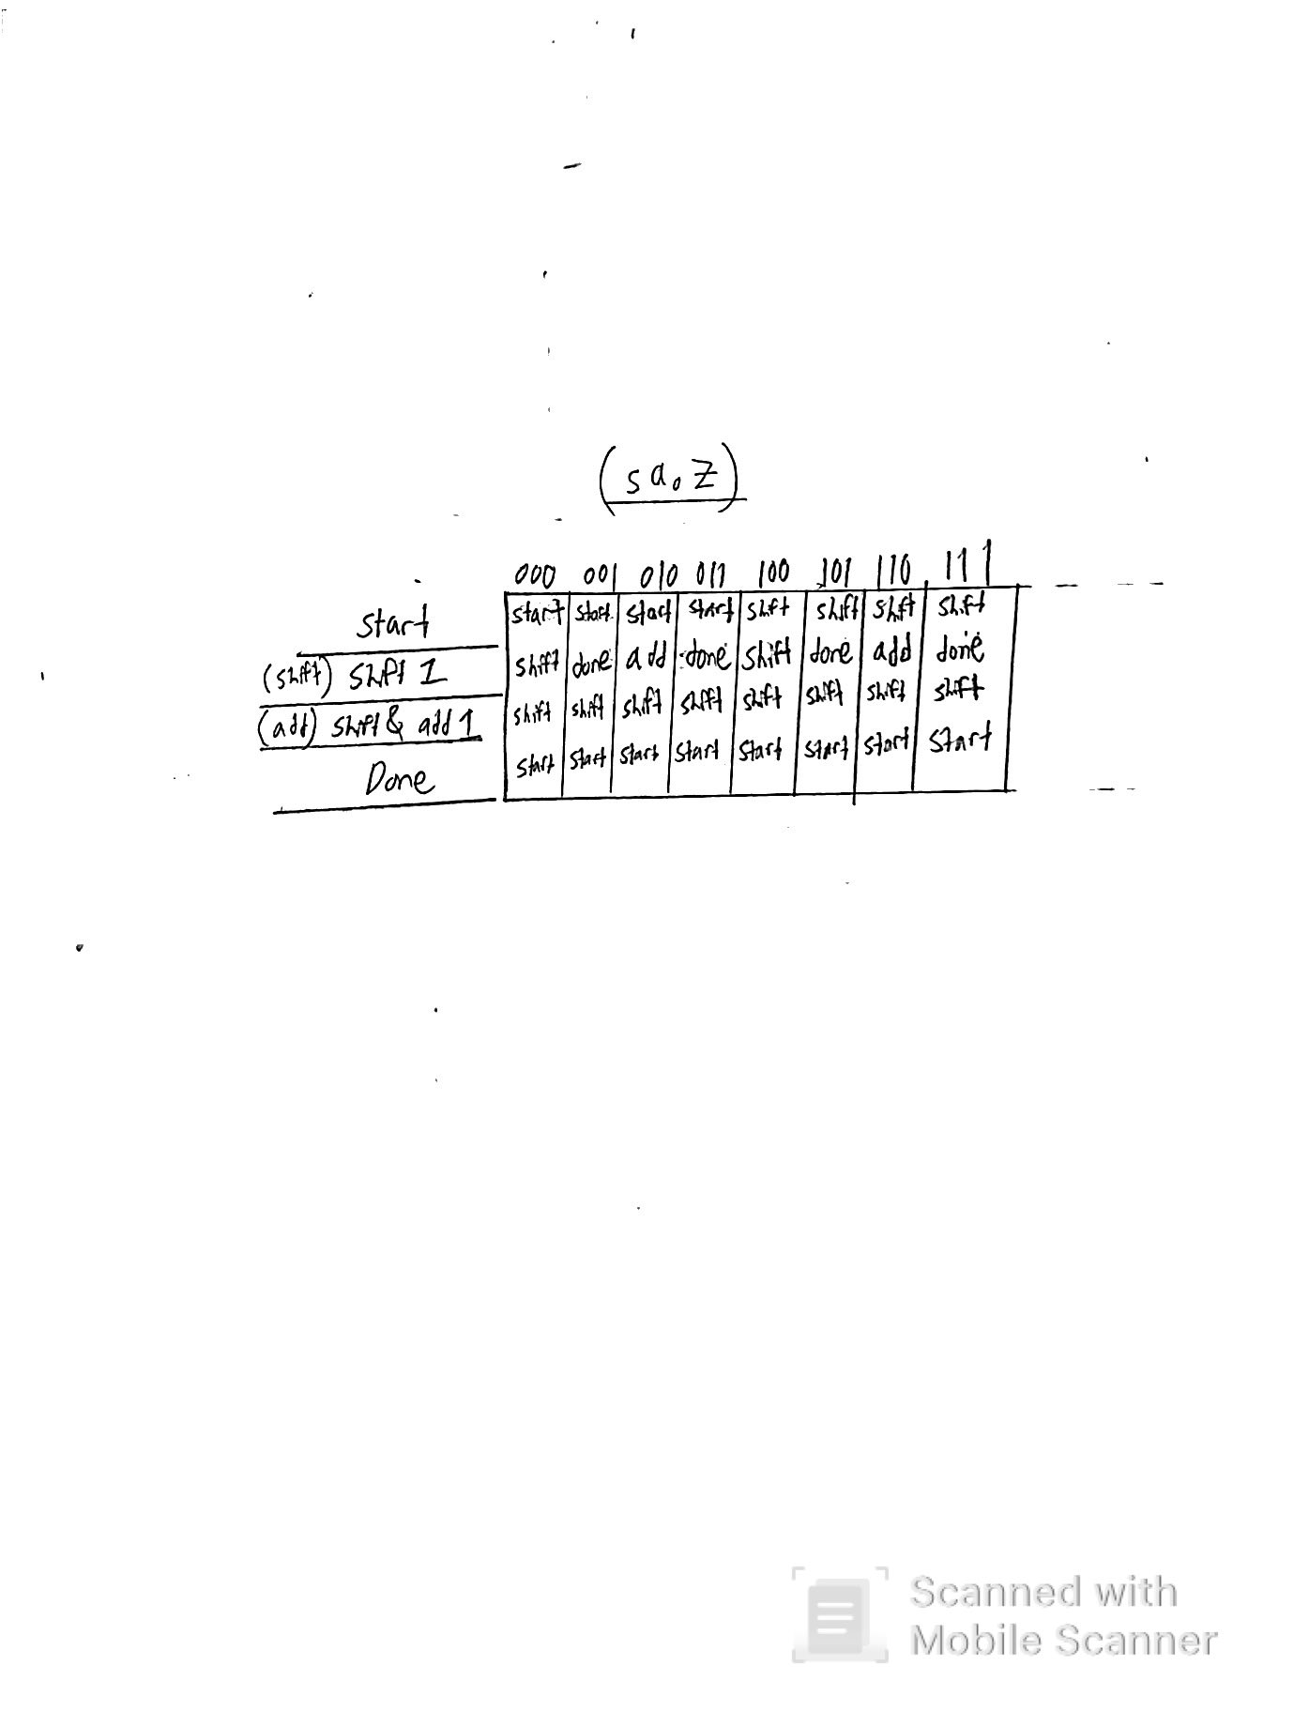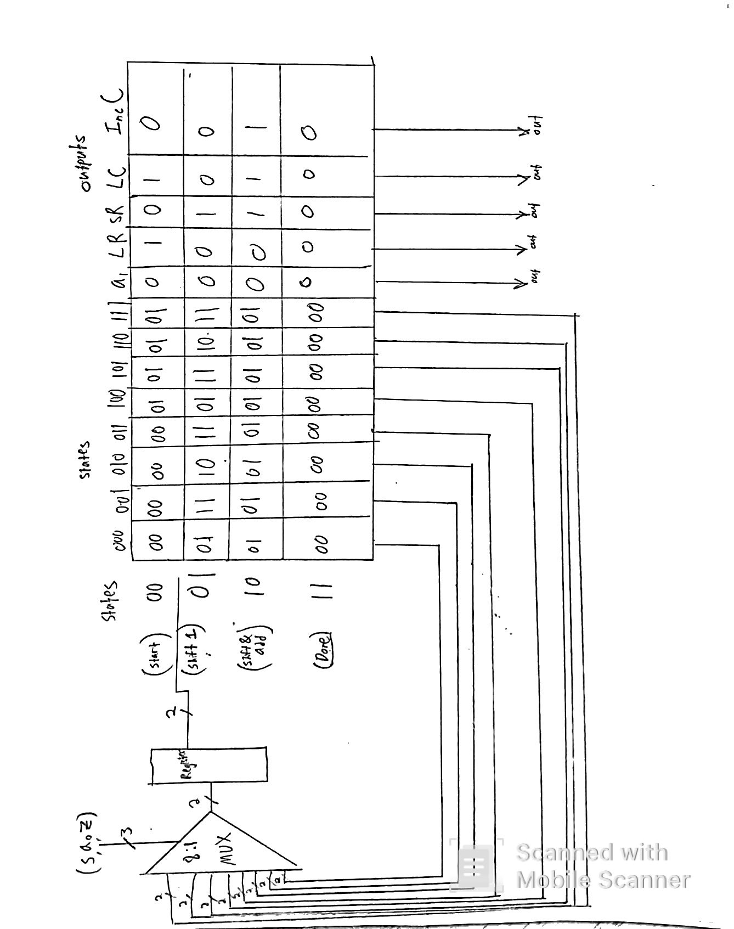

# Problem II MIPS SPIM Simulation

To simulate Exercise 5, the original code had a number of errors. First, it would have addressed an array out of bounds by first looking adding MyArray[-1] to MyArray[1]. To fix this, I started the addressing at 1 and then had to add one more value to the beginning of the array. Then, because it wanted to do 10 additions, I had to add another value at the end for 12 total values. Also, the subroutine subtracted 10 but didn’t say what to do with that value so I put it into a temporary register $t6 as if it were somehow being stored somewhere because the code didn’t say to store it anywhere. The code for this is here and there are screenshots. It was odd but the loop modified a value at [i] that it later used in adding for the next [i+1] so it didn’t seem like this code does much.

Note: I had to search up how to create a program for main on the internet and support pages for QtSPIM.

.data

MyArray: .word 0x00000001

.word 0x00000002

.word 0x00000003

.word 0x00000004

.word 0x00000005

.word 0x00000006

.word 0x00000007

.word 0x00000008

.word 0x00000009

.word 0x0000000a

.word 0x0000000b

.word 0x0000000c

.text

.globl main

.ent main

main:

la $s1, MyArray

li $t0, 10

li $t1, 4

li $t2, -4

li $t3, 1

loopstart:

ble $t0,0,loopend

subu $t0,$t0,$t3

add $s1, $s1, $t1

lw $t4, 4($s1)

lw $t5, -4($s1)

add $t4, $t4, $t5

sw $t4, 0($s1)

jal subtract10

li $t6,0

or $t6,$t4,$t4

b loopstart

loopend:

li $v0, 10

syscall

.end main

subtract10:

li $t5, 10

sub $t4,$t4,$t5

jr $ra

.end subtract10

Screen Shots before running the code and after loading it into QtSPIM.

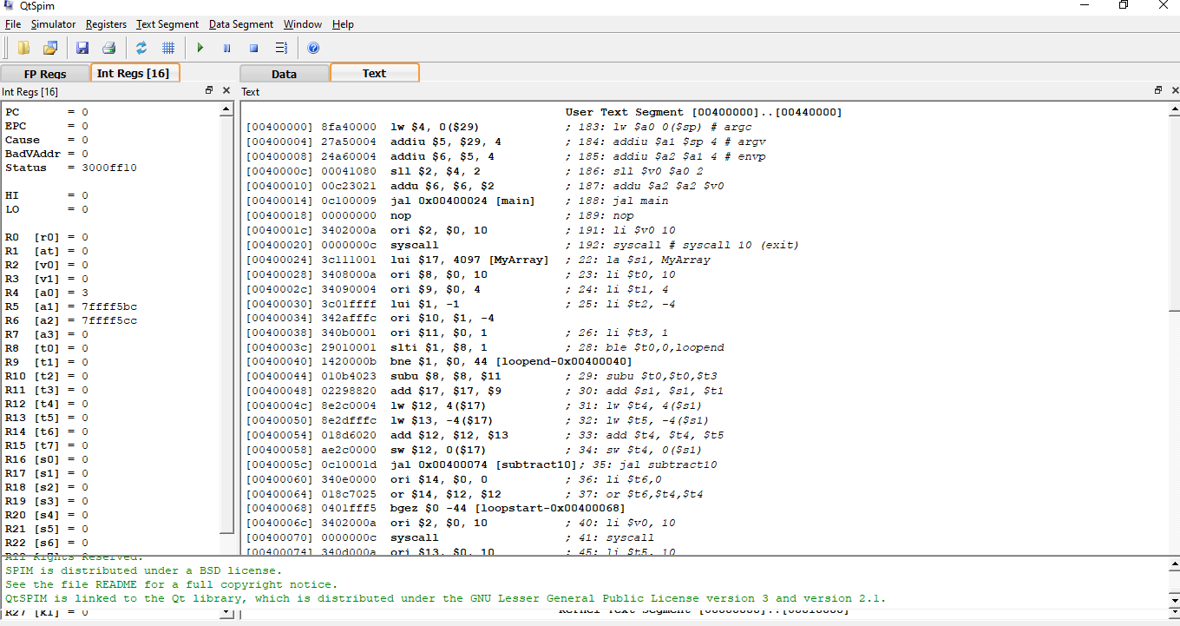

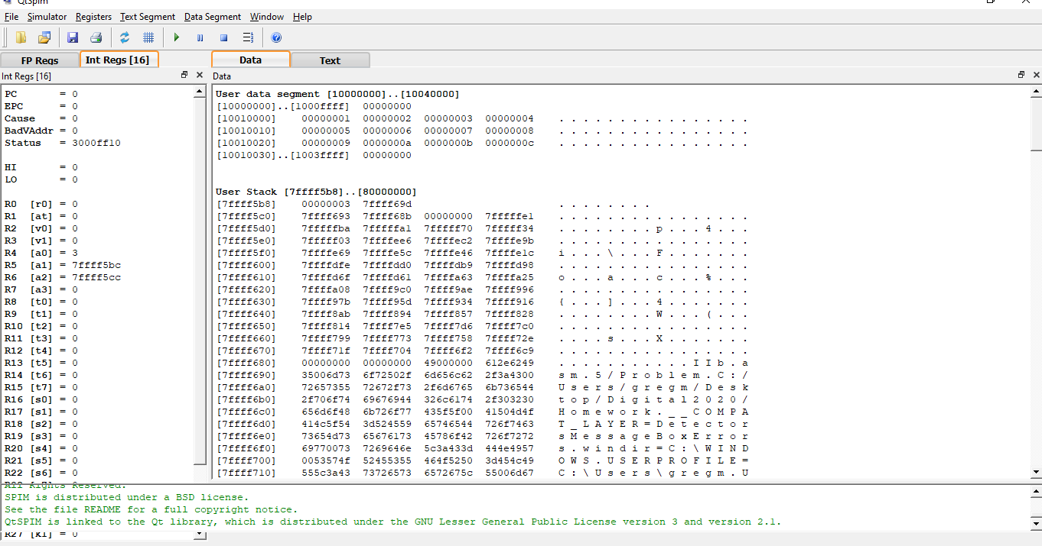

Screen Shots after running the code and after loading it into QtSPIM.

